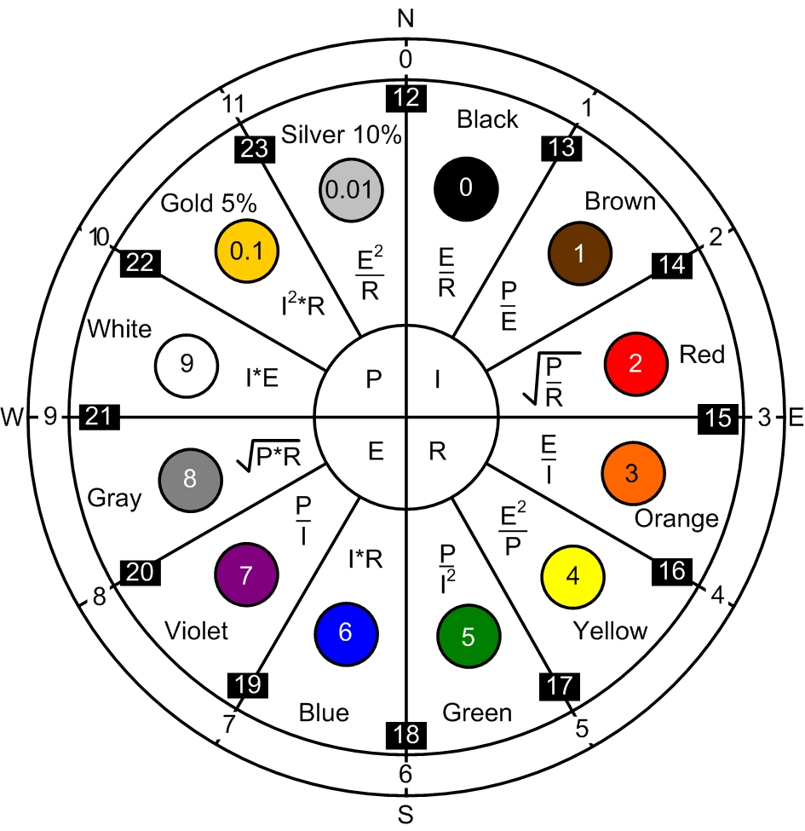
Power, Current, Voltage, Resistance Equations

Also the resistor color code
[Bad beer rots our young guts but vodka goes well – get some now]
and a 24-hour clock primer

